Visual Studio set up for Custom SOA

# Description:

This document helps to make the configuration for doing Custom SOA creation outside the BMIDE (in Visual Studio)

# Pre-requisites:

Custom SOA project should be ready in the BMIDE.

**Step1:** Create a Win32 DLL project in the visual studio

**Step2:** Add a new header file and source file

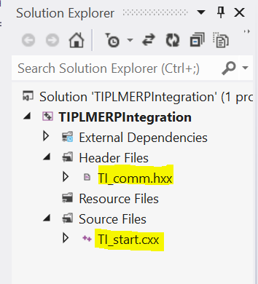

**Step3:** Set the properties of project as shown in the below snap

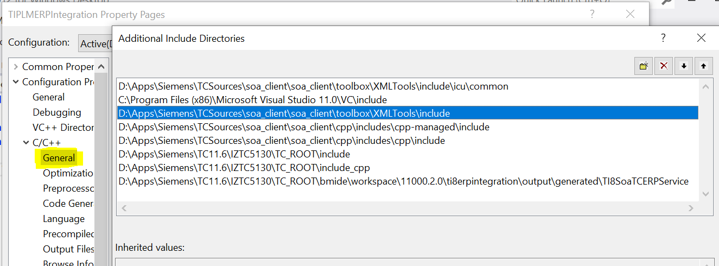

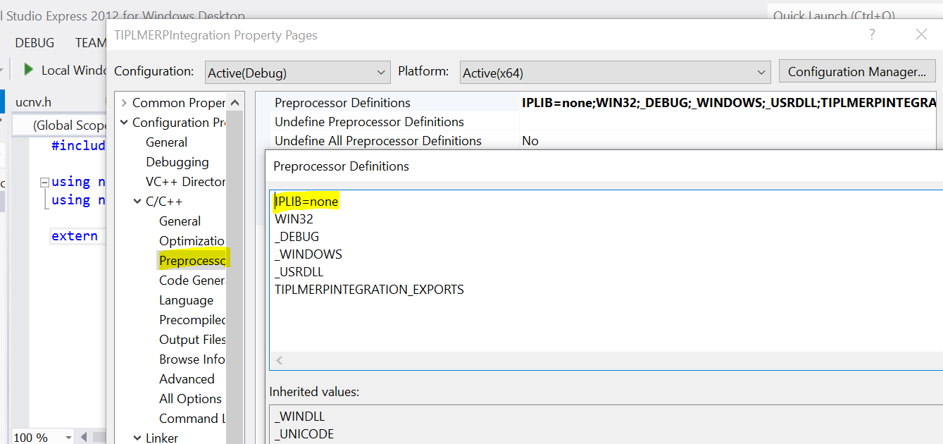

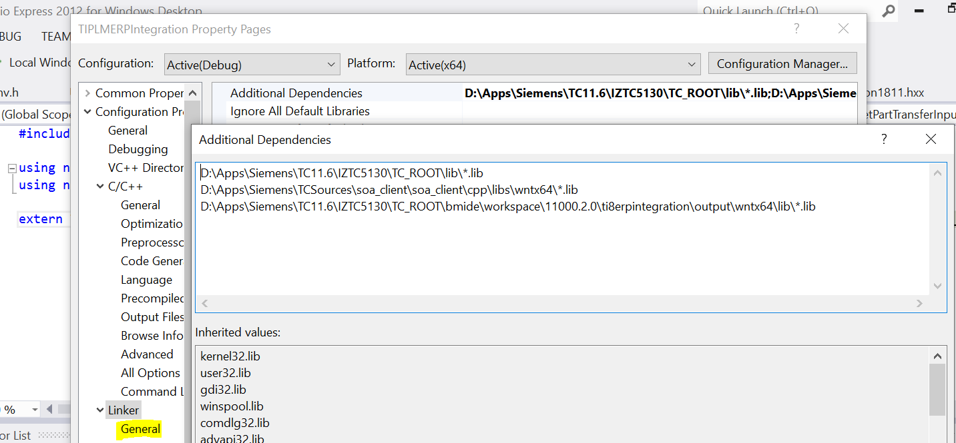

**Step4:** Add the following things in the header file in Visual Studio

#include <titcerpextension1811.hxx> //Add the header file name in BMIDE

using namespace TI8::Soa::TCERPService::_2018_11;

using namespace Teamcenter::Soa::Server; //Use the namespace from BMIDE code

extern TI8::Soa::TCERPService::_2018_11::TITCERPExtension::GetPartTransferResponse tiPartTransfer(TI8::Soa::TCERPService::_2018_11::TITCERPExtension::GetPartTransferInput getpart);

**Step5:** Add the following things in the source file in Visual Studio

#include "TI_comm.hxx"

extern TI8::Soa::TCERPService::_2018_11::TITCERPExtension::GetPartTransferResponse tiPartTransfer(TI8::Soa::TCERPService::_2018_11::TITCERPExtension::GetPartTransferInput getpart){

/* Code your logic*/

TITCERPExtension::GetPartTransferResponse outputRes;

return outputRes;

}

**Step6:** Do the below changes in the BMIDE project

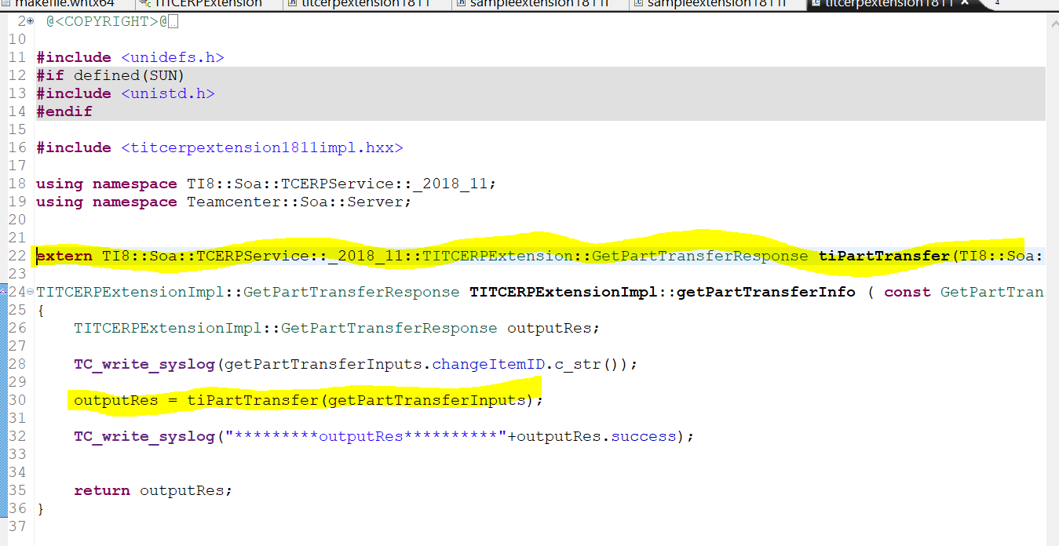

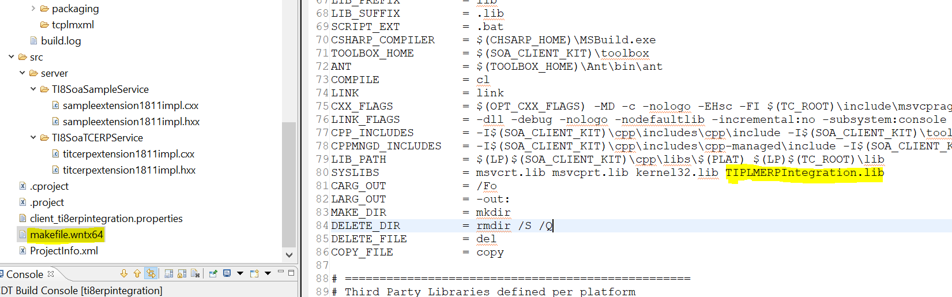

# BMIDE Project properties configuration:

